Report of Departmental Activities for the session 2021-2022

Webinar on Urban Morphology and Aesthetics of Shahjahanabad
September 3, 2021
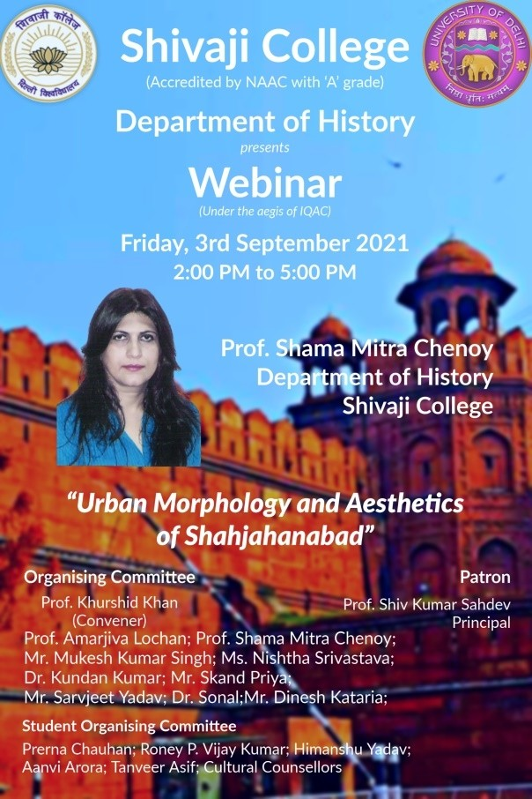
In the event, Professor Shama Mitra Chenoy gave a virtual tour of the city across space and time. She spoke about the city, its people and cultural legacy of Delhi. Inaugurated by the Principal Professor Shiv Kumar Sahdev, the session was chaired by Professor Khurshid Khan. The webinar was attended by over 70 participants and was followed by an interactive discussion. The webinar ended with a vote of thanks delivered by Dr. Kundan Kumar.

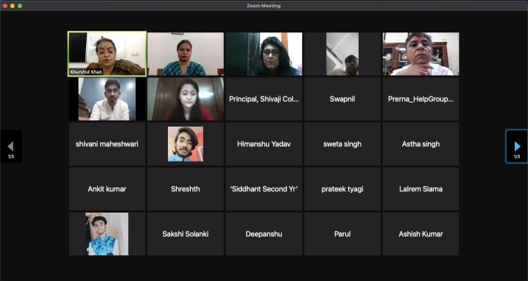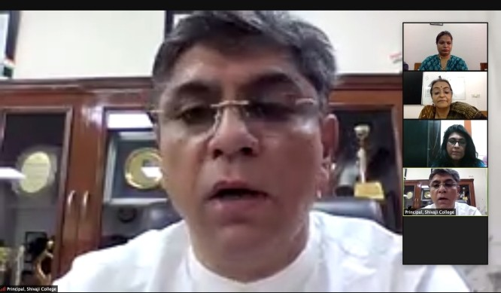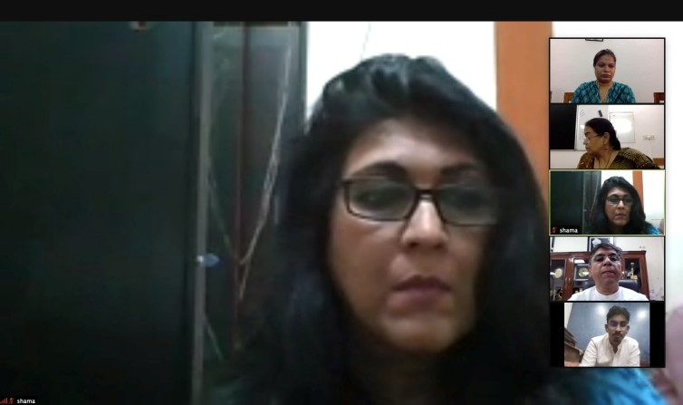

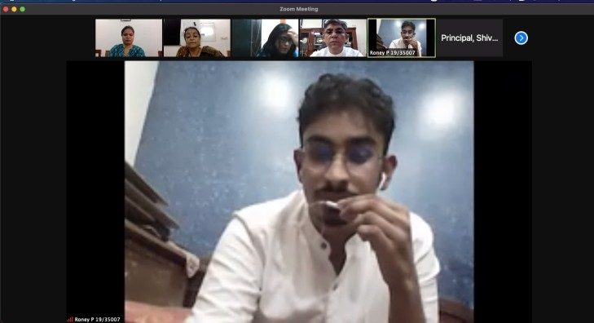

Webinar on Climate Crisis: Past Trajectories- Contemporary Dilemmas

November 24, 2021

Prof. Mayank Kumar, School of Social Sciences, IGNOU, speaking on the theme highlighted human exploitation of the environment and the disasters that humankind is facing. He suggested the extreme measures that are required to stall the process. The webinar was attended by over 70 participants. The talk was followed by an interactive session. It was inaugurated by the Principal, Professor Shiv Kumar Sahdev and it ended with a vote of thanks delivered by the teacher-in-charge, Professor Khurshid Khan.

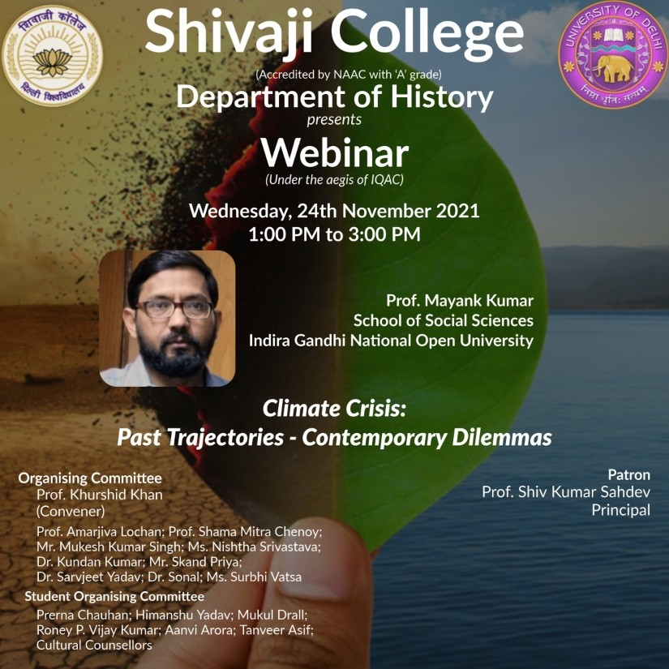
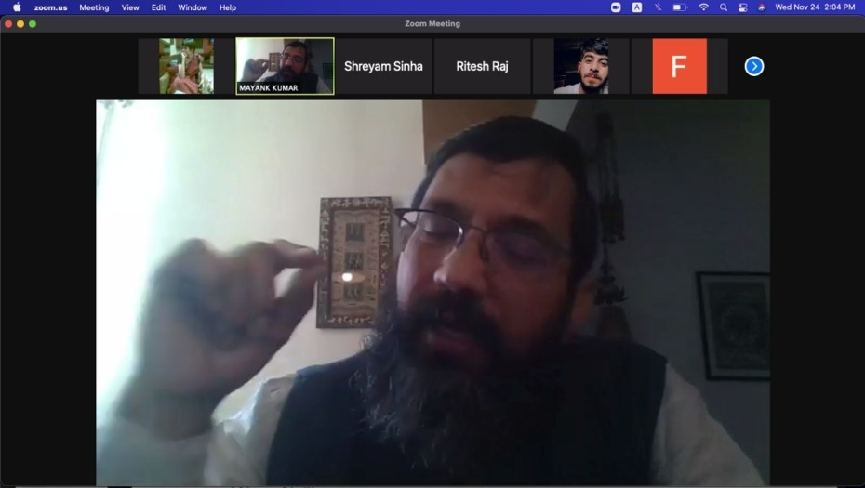

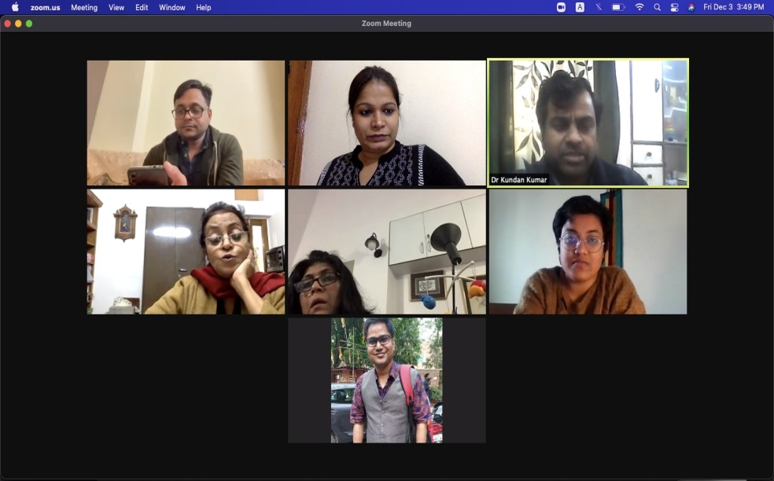

Online Film - Screening and Review Competition
January 14, 2022
The Department conducted an online Film - screening and review competition for the students of the Department on the Microsoft Team platform. Over eighty members joined the film- screening and forty eighty students participated in the review competition. The film- screening was followed by a discussion amongst the students and faculty members. Three best reviews were selected for cash prize awards.

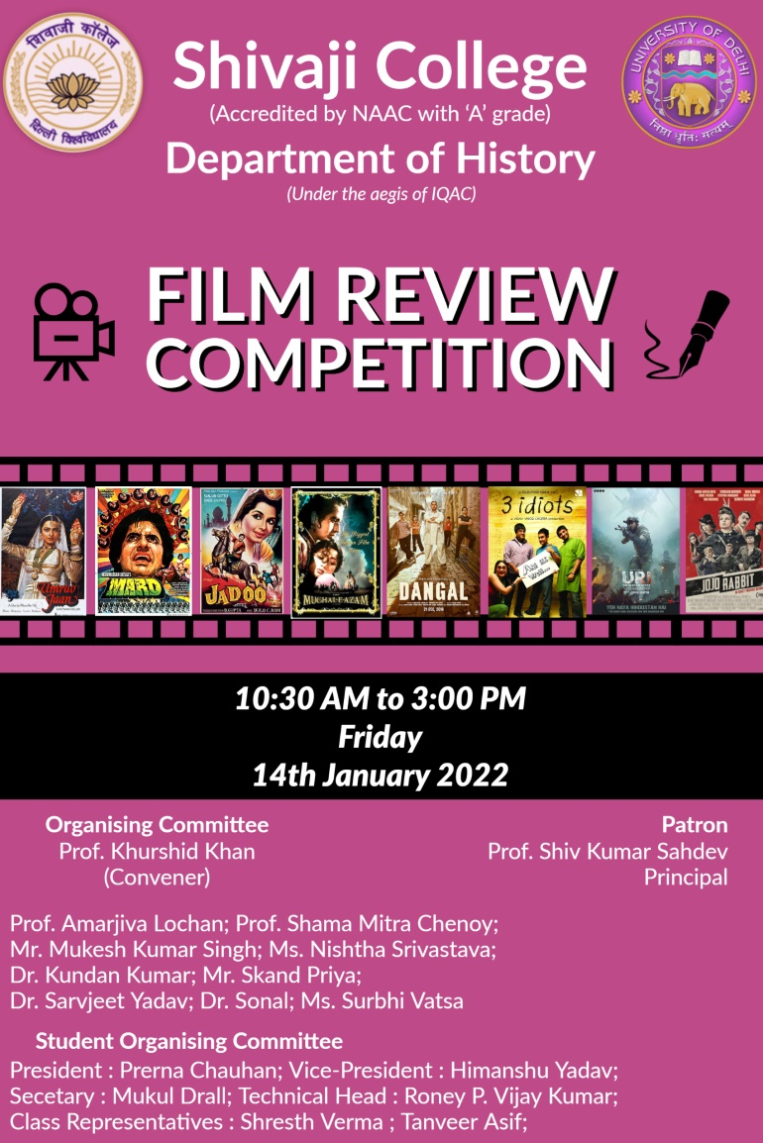

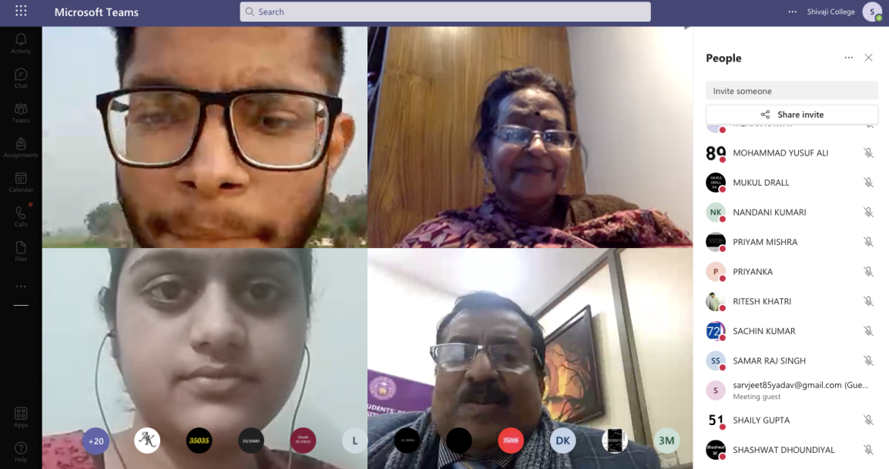

Webinar on Viewing the History of India through the Prism of the Horse January 24, 2022
The webinar was declared open by the Principal, Shivaji College. More than 80 participants joined the webinar chaired by Professor Khurshid Khan. Dr. Yashawani Chandra, Fellow, CSDS, traced the history of horses and their symbolic power and grace woven in mythology, art and folklore of the Indian subcontinent. The resource person opened up the subject of history in the context of an analysis of novel cultural symbology of horses. The talk was followed by an interactive session. The session ended with a vote of thanks.
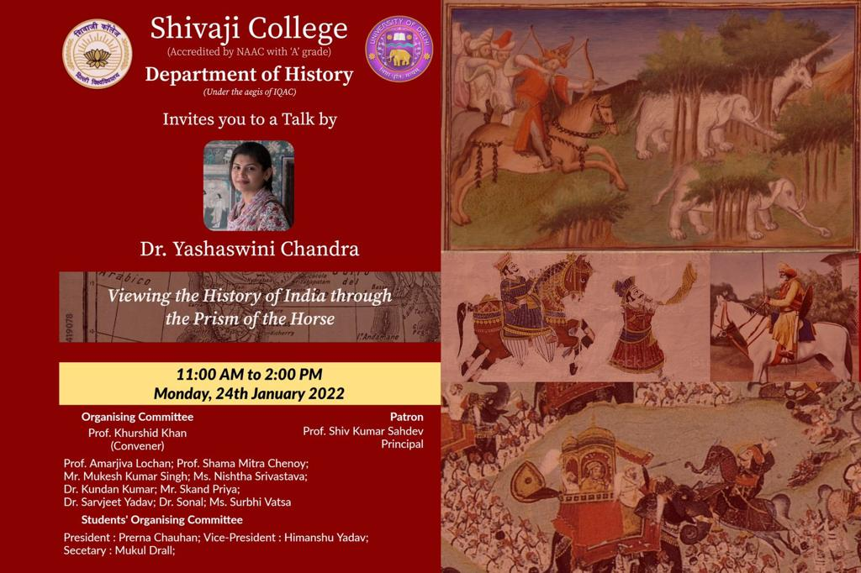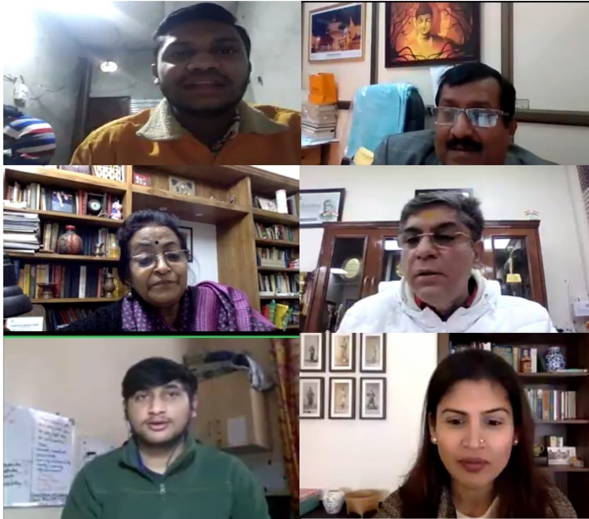

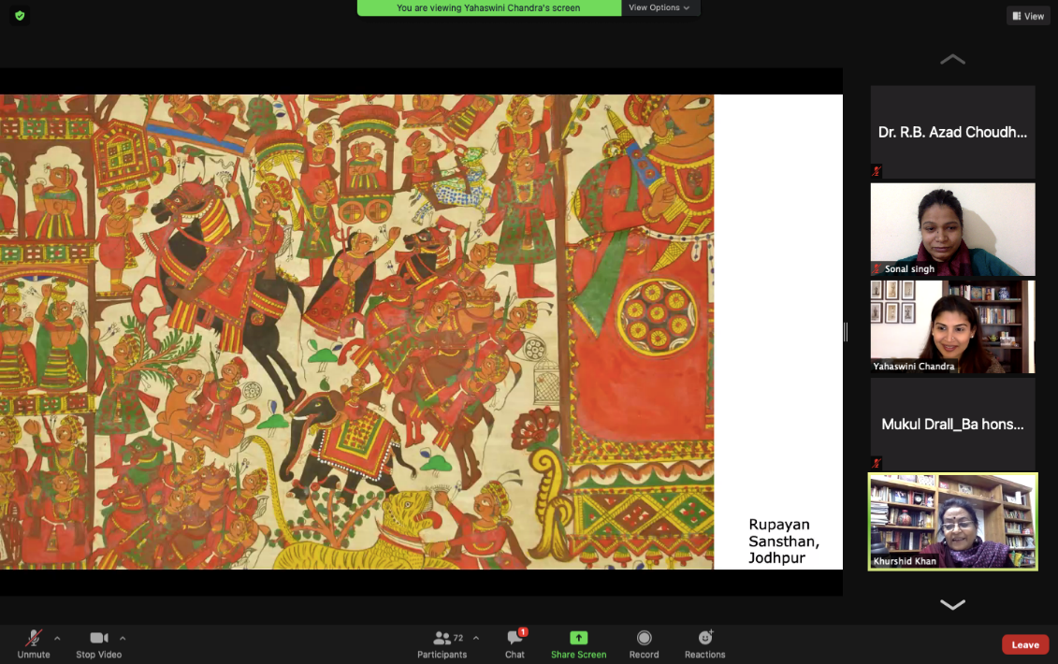

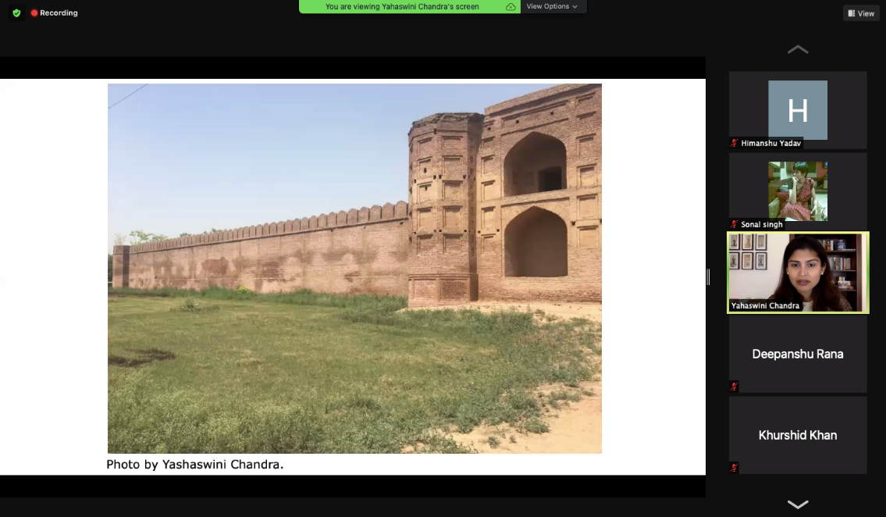

Heritage Walk
March 03, 2022

The department organized a heritage walk- cum- academic excursion to Birla Mandir, Humayun’s Tomb and Lodi Garden. The faculty members along with students from all three years commenced the walk from the college, in two buses. Faculty members informed the students about the importance of our rich heritage. They were also acquainted with the evolutions of various architectural styles and the meanings and interpretations of the styles itself. The heritage walk was part of experiential learning of our students, as it is the demand of our subject curriculum.

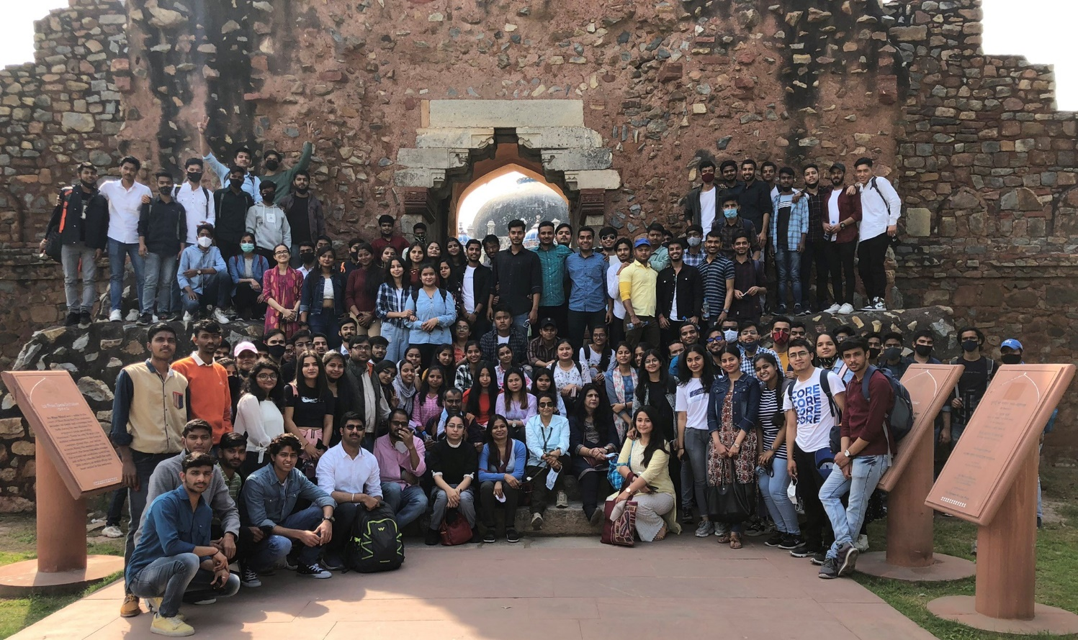
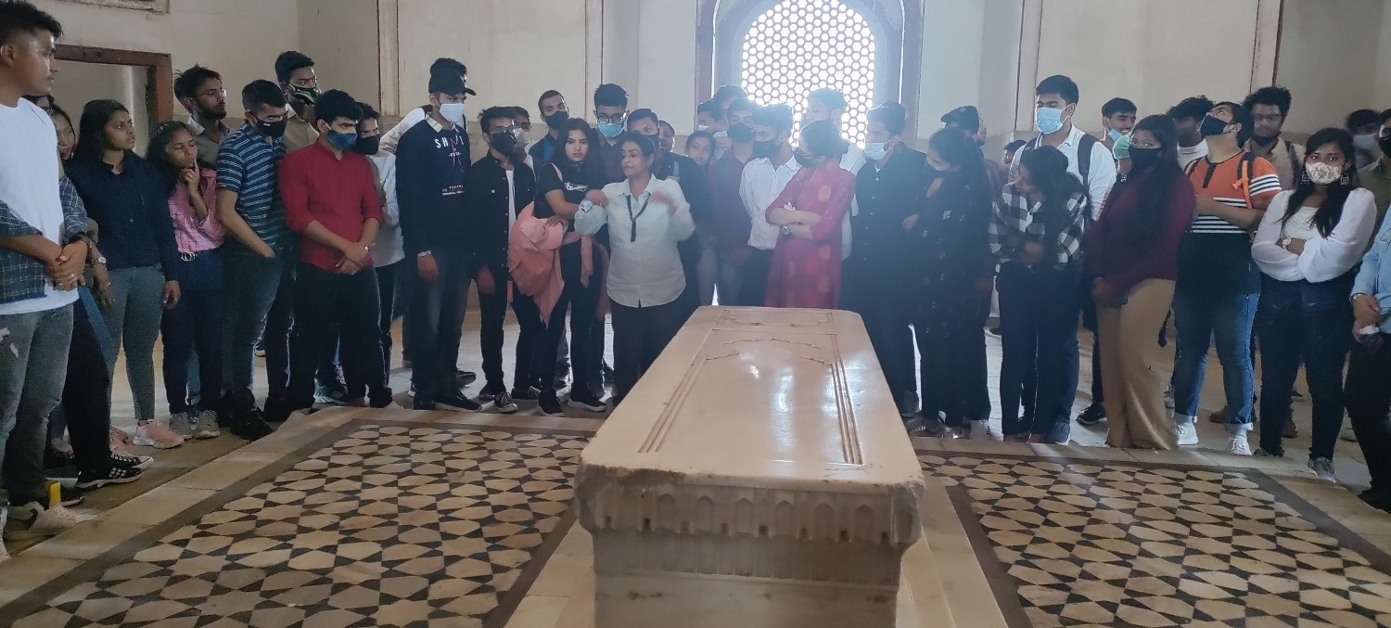

Online Induction of the Freshers’, Department of History, 2021-22
February 10, 2022

The History department held an induction programme for the batch of freshers, of the academic session 2021-2022 batch. The faculty and students welcomed them. The senior students gave them a virtual tour of the college premises, to the freshmen and women. They were acquainted with the various facets and activities of the department. The new batch participated enthusiastically, showcasing their talent of dancing, singing, acting and poetry-writing and recital in the event. Their seniors interacted with them, through fun games organized during the event.

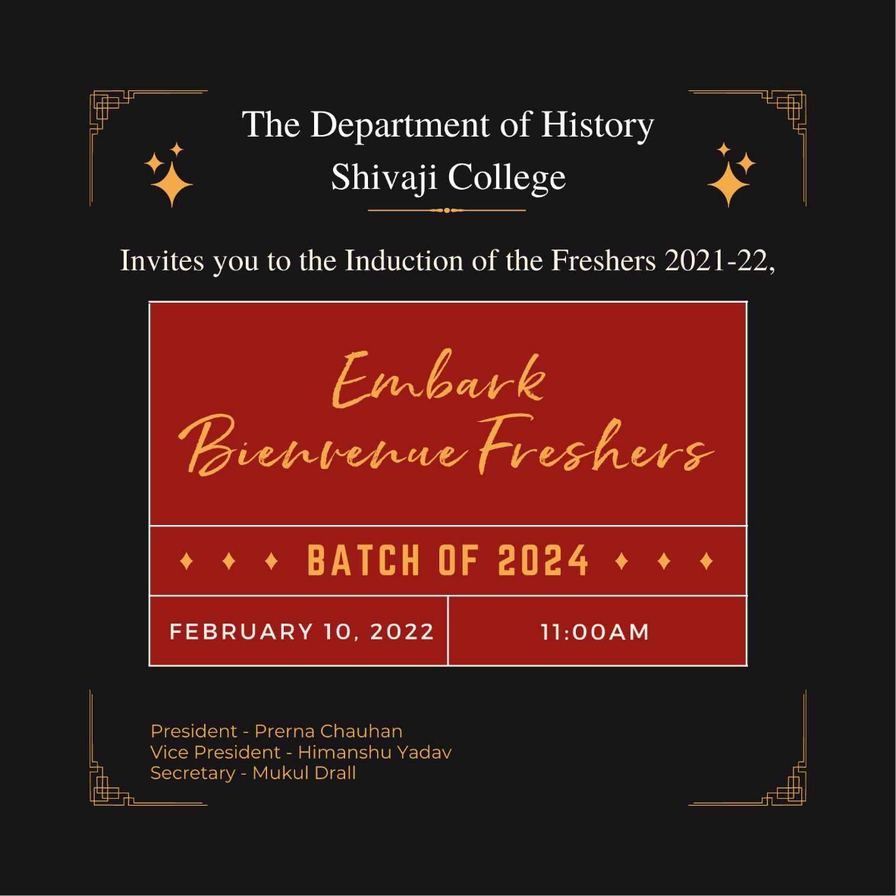

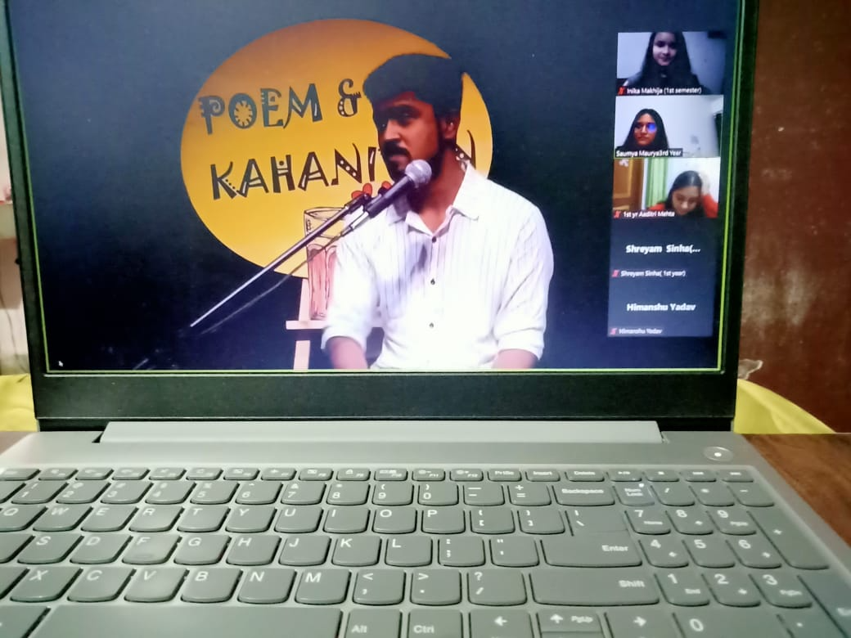

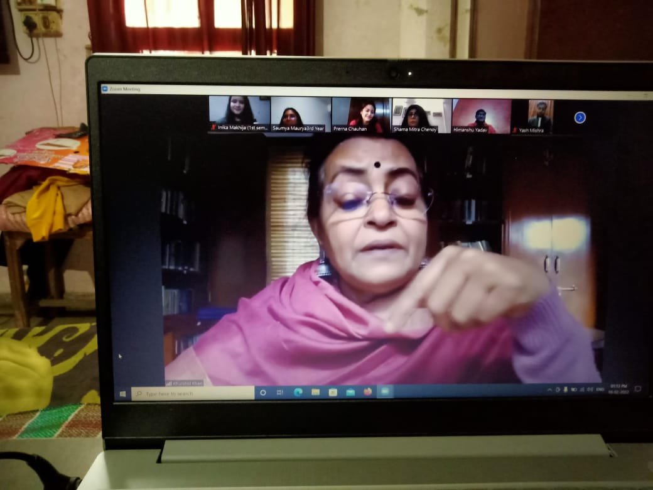

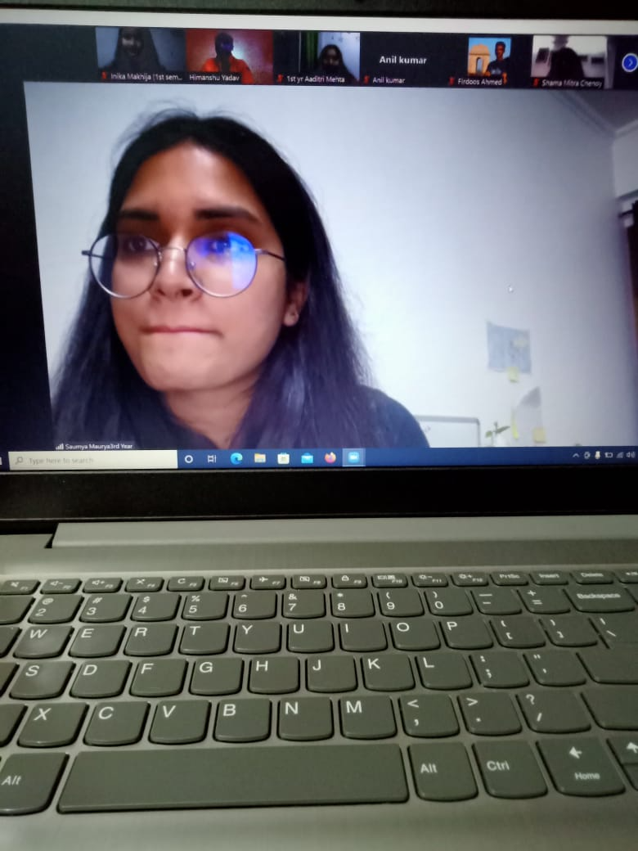

Students’ Annual Competitive Events
March 10, 2022
This event was organized by the teachers and the student council of the Department. There were four competitions: Painting, Slogan Writing, Character Play and Quiz. The event started around 9:00 am and ended around 4pm. Teachers were the judges of these events. Participation certificates and prizes were given.

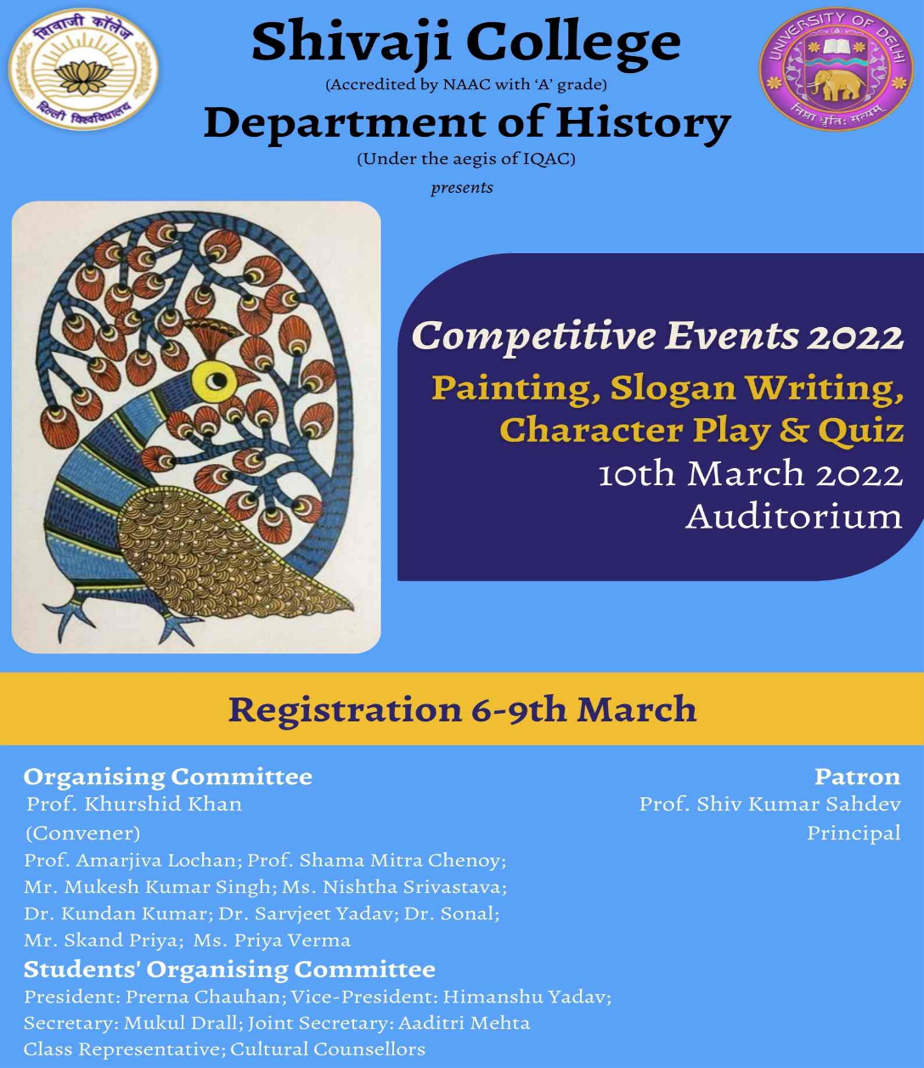

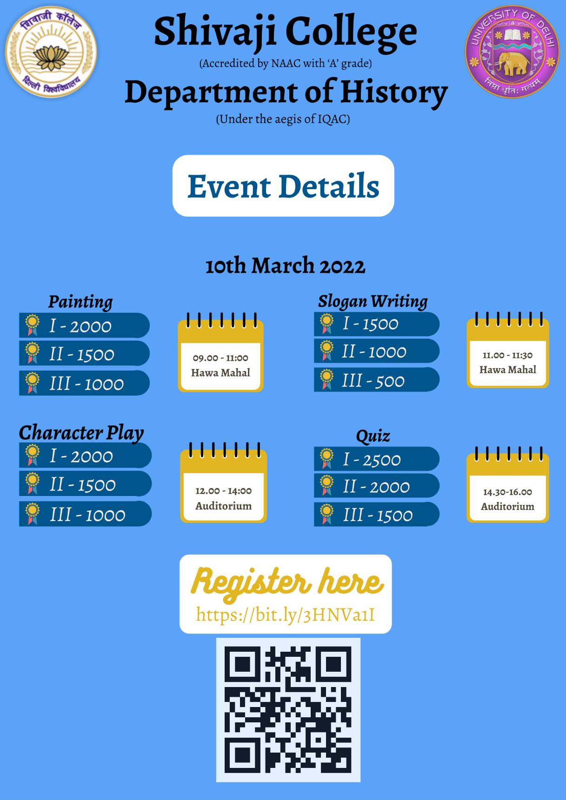

Seminar on What is a Nation?
April 19, 2022
The talk was delivered by Professor Anirudh Deshpande, Department of History, University of Delhi. The seminar was attended by over a hundred participants. In the opening remarks, the teacher-in-charge, Professor Khurshid Khan, and the resource person reminiscenced the work and academic life of late Professor Bhairabi Sahu. The session was moderated by Professor Shama Mitra Chenoy and vote of thanks was proposed by Ms. Nishtha Srivastava.

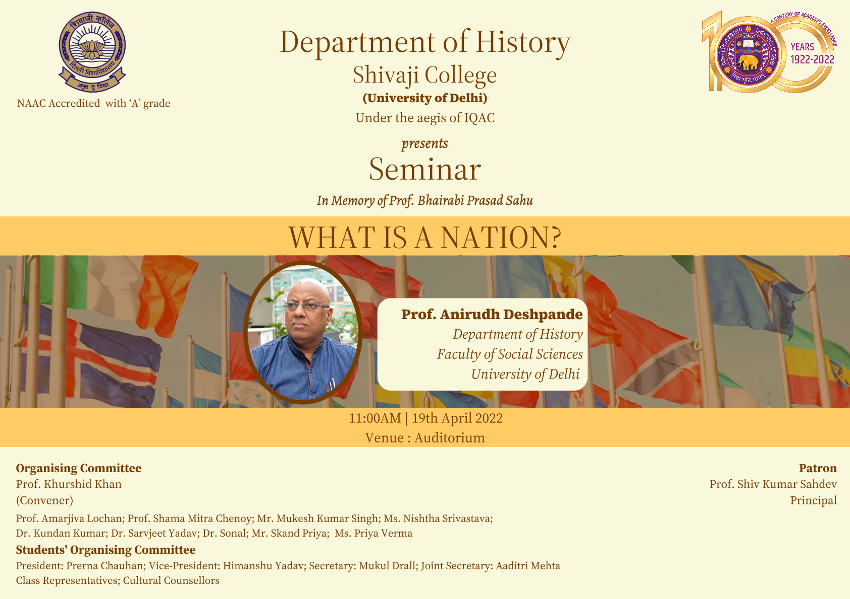

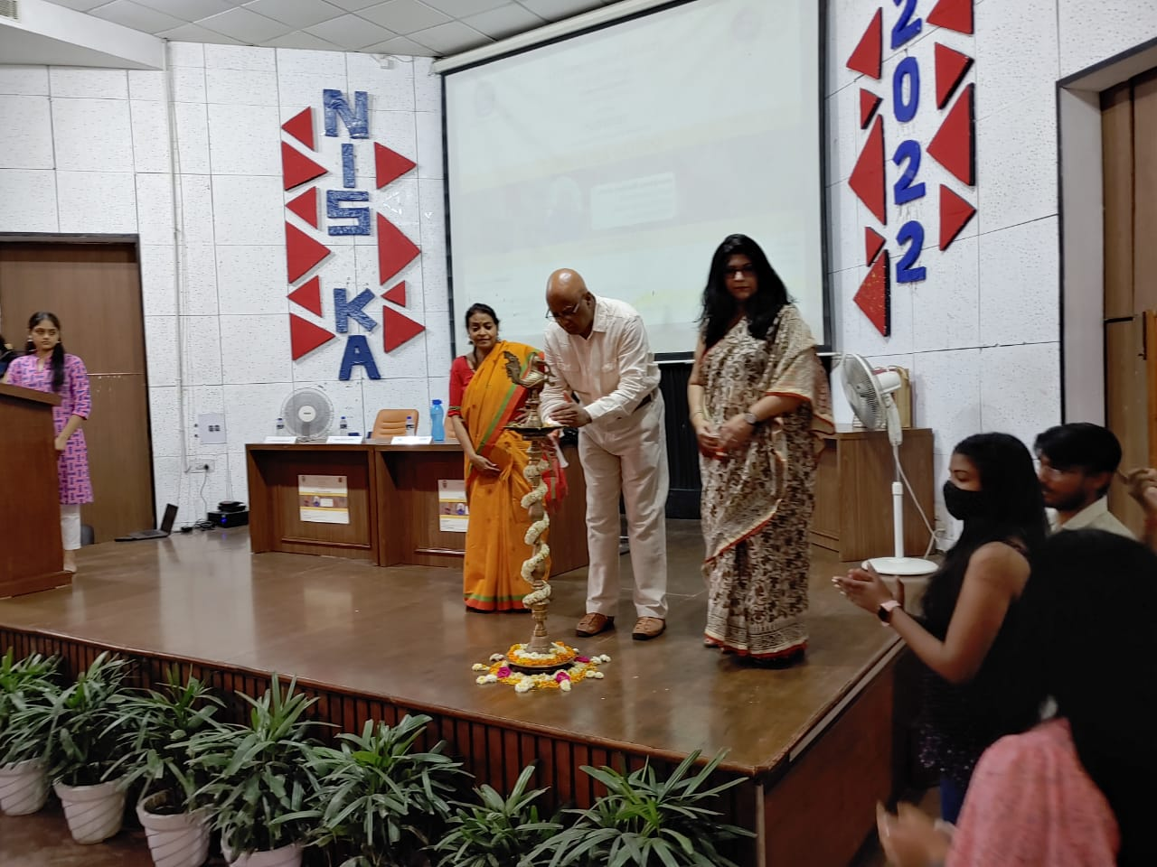
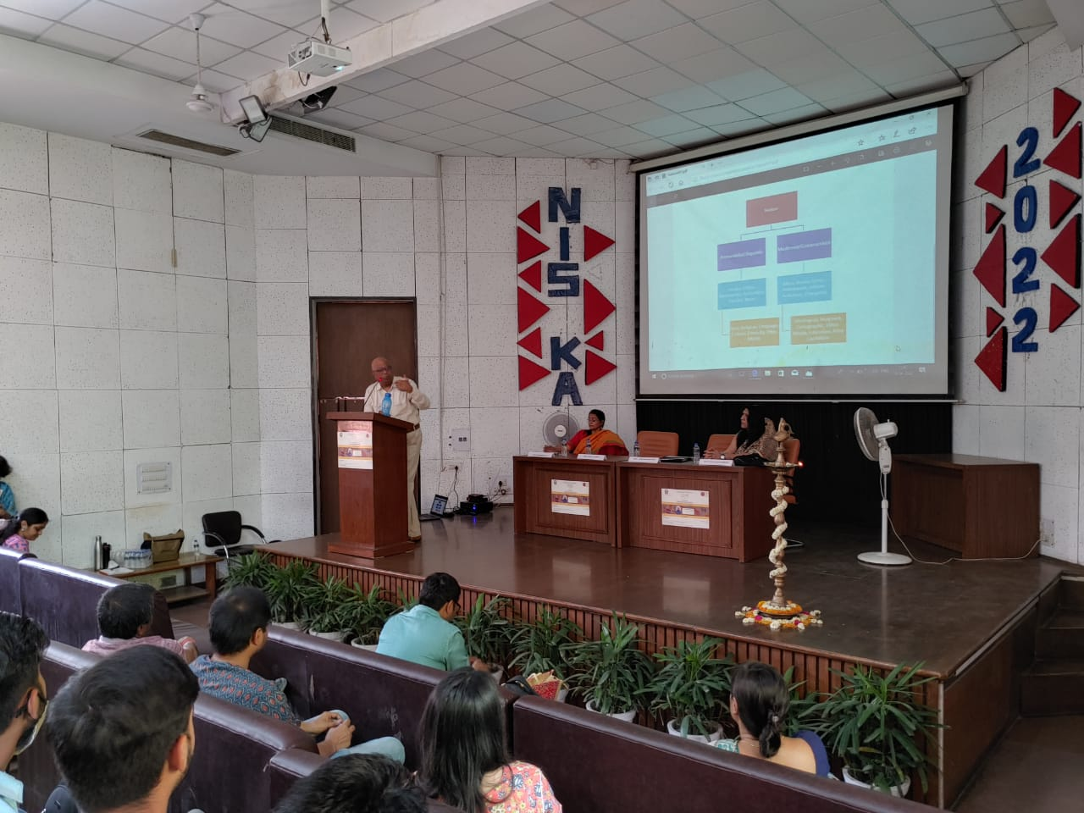

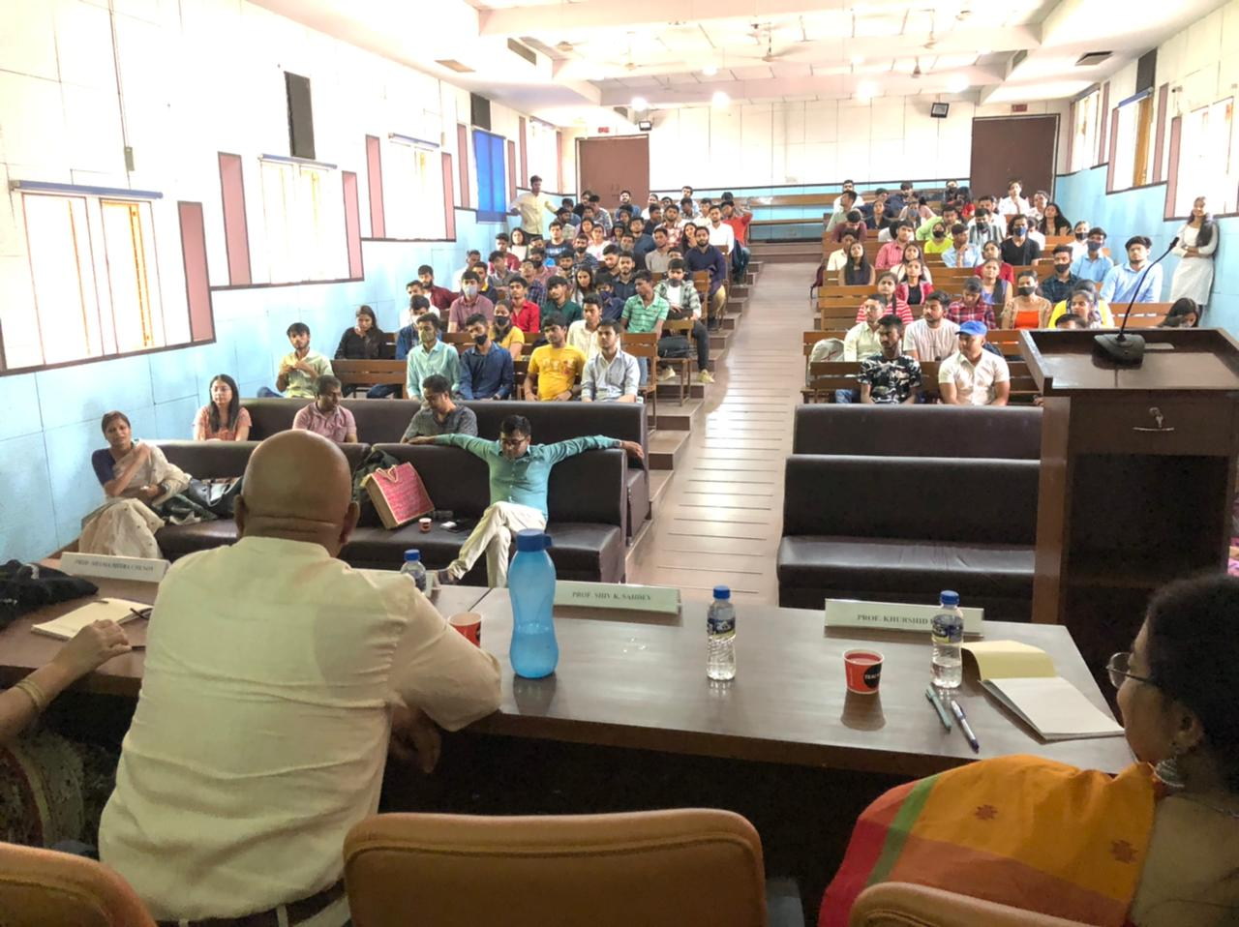

Virtual Departmental Alumni Meet
April 24, 2022
More than 50 alumni from across the country and the globe attended the event including prominent alumni of the department, Mr. Anjani kumar IFS. Currently Ambassador to Mali, Mr. Kumar addressed the meet with many others, working in various fields. Mr. Anjani Kumar gave his insights on how the Foreign Service entails facilitating an understanding between India and other nations at diverse levels, ranging from culture, and economics to politics. Senior faculty members including Prof. Khurshid Khan and Prof. Amarjiva Lochan addressed the gathering. Prof Shama Mitra Chenoy moderated the meet. The programme concluded with a vote of thanks proposed by Ms. Nishtha Srivastava. The present students interacted with the alumni who apart from reminiscing about time spent in college, guided them as to how to take up a good career, and be happy in what students would choose to do in life.

